**User Guideline Document for *Dungeons and Wishes***

**1. Introduction**

**2. System Requirements (Windows)**

**Minimum Requirements**

* OS: Windows 7 SP1+ (64-bit)
* Processor: Intel Core i3-2100 or AMD equivalent
* Memory: 4 GB RAM
* Graphics: Intel HD Graphics 4000 or equivalent (integrated GPU)
* DirectX: Version 10
* Storage: 2 GB available space
* Display: 1280x720 resolution minimum
* Input: Keyboard and mouse

**Recommended Requirements**

* OS: Windows 10 or 11 (64-bit)
* Processor: Intel Core i5-8400 / AMD Ryzen 5 2600 or better
* Memory: 8 GB RAM
* Graphics: NVIDIA GeForce GTX 950 / AMD Radeon R7 370 or better (dedicated GPU)
* DirectX: Version 11
* Storage: 8 GB available space
* Display: 1920x1080 resolution
* Input: Keyboard and mouse, with optional gamepad support

**3. Installation and Launch Instructions**

**Installing the Game**

1. Visit the official https://github.com/PrabalGurung/DungeonAndWishesV1
2. Click on the green "Code" button, then select "Download ZIP".
3. Once the ZIP file is downloaded, right-click it and choose "Extract All..." to unzip the folder.
4. Open the extracted folder.

**Launching the Game**

1. Inside the folder, locate the file named DungeonsAndWishes.exe.
2. Double-click the file to launch the game.
3. If a Windows security prompt appears, click "More info" > "Run anyway".

***Tip:*** *You can right-click the .exe file and choose “Send to > Desktop (create shortcut)” to make launching the game easier in the future.*

**4. Game Overview**

* Genre and style (e.g., "2D Top-Down Fantasy RPG").
* Objective of the game.
* Short backstory/lore (if needed).

**5. Controls**

|  |  |
| --- | --- |
| **Action** | **Keyboard/Mouse Input** |
| Move Character | WASD / Arrow Keys |
| Interact | Z |
| Open Inventory | Tab |
| Back | X |

**6. User Interface Explanation**

* Annotated screenshot showing:
  + Inventory UI

* + Setting UI

* + Stats UI

* + Map UI

* + NPC:

* + Items:

* + Dialogue box

* + Battle menu (turn-based)

* + Item UI

* + Skill UI

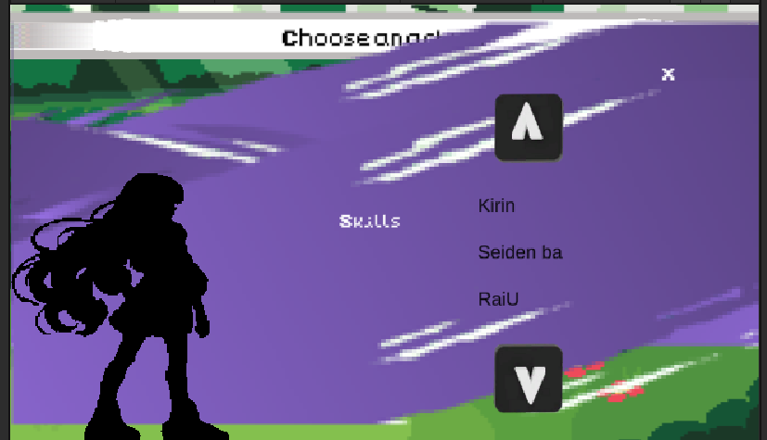

* + Status Bar

* + Dialouge box UI Turn base:



**7. Gameplay Mechanics**

**Movement & Exploration:** Players can navigate the world using intuitive controls for exploration, including movement through towns, dungeons, and outdoor environments.

**Combat System:** A turn-based combat system allows players to plan strategic attacks and defenses against enemies.

**Inventory Management:** Players can collect, equip, use, or drop items from their inventory to enhance their character’s abilities and progress.

**Dialogue:** Engaging dialogue with NPCs unfolds the story, offering choices that influence the narrative and character relationships.

**Battle Encounters:** Randomly triggered battles keep the gameplay dynamic and offer players varied challenges as they explore.

**Saving & Loading Progress:** The game offers both manual and auto-save features to ensure players can preserve their progress.

**Buying & Selling:** NPC merchants offer a variety of goods for purchase, each with unique items that players can use or sell for profit.

**Auto Generated Map:** Randomly generated cave systems and environments ensure that each playthrough feels unique and challenging.

**Different Monsters & Skills:** A wide range of monsters, each with distinct abilities, challenges players to adapt their strategy and skills.

**Sound System:** An immersive sound design enhances the game atmosphere with background music, sound effects, and voice acting.

**Score Difficulty System:** The AI adapts to the player’s performance, increasing in difficulty as the player improves, providing an ongoing challenge.

**Player Progress Bar:** As the player gains experience, a progress bar tracks their growth, allowing them to level up and unlock new abilities.

**Environment Interaction:** Players can interact with the environment to solve puzzles, trigger events, and discover hidden paths.

**Hidden Secrets and Easter Eggs:** Hidden secrets and easter eggs offer additional rewards and unlockables for curious players.

**Unlockable Skills & Powers:** Players can unlock new skills and powers throughout the game, enhancing their combat abilities and gameplay experience.

**8. Common Issues / FAQs**

* Game won’t start?
* How to save/load?
* Can’t interact with object/NPC?

**9. Tips for Beginners**

* Don’t skip dialogues—they may contain hints.
* Save often before entering a dungeon.

**10. Contact & Support**

* Email for reporting bugs or feedback through the main menu page of the game.